Project Development Phase
Performance Test

Date | 12 February 2026
Team ID | LTVIP2026TMIDS53912
Project Name | Visualization tool for electric vehicle charge and range analysis.
Maximum Marks

Model Performance Testing:
S.No. | Parameter | Screenshot / Values
1 | Data Rendered | The UNESCO World Heritage Sites (2019) dataset was successfully rendered in Tableau Desktop. All fields including Site Name, Country, Region, Category (Cultural/Natural/Mixed), Year of Inscription, Latitude, and Longitude were loaded correctly without errors.  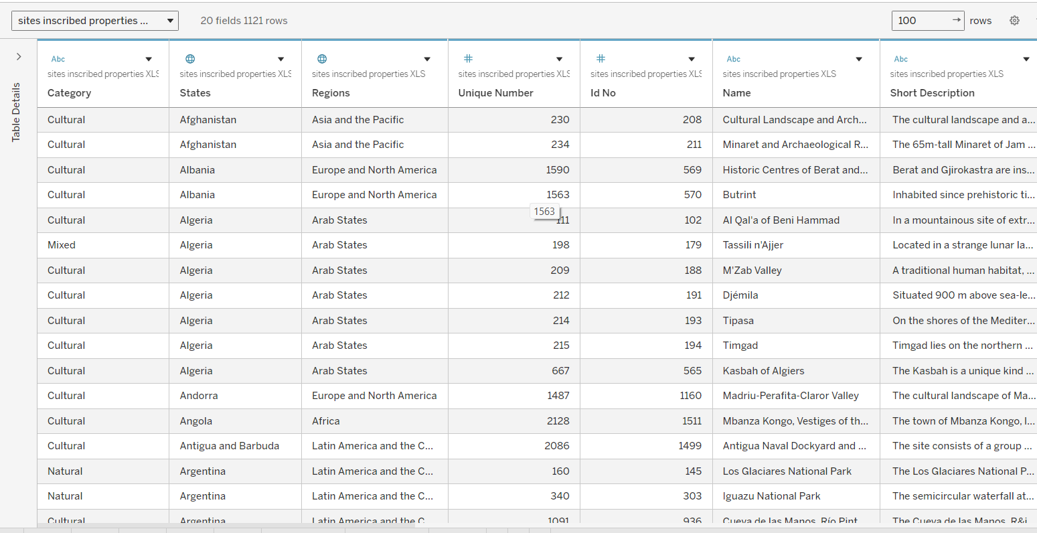
2 | Data Preprocessing | Data preprocessing was performed by handling missing values, removing duplicate site entries, correcting data types (Year, Geographic fields), and creating calculated fields. Country names and categories were standardized and unnecessary columns were removed before visualization.  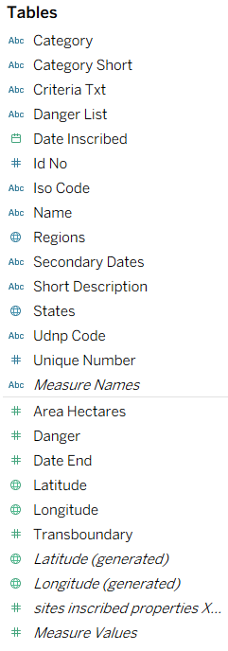
3 | Utilization of Filters | Filters such as Country, Region, Category (Cultural/Natural/Mixed), and Year of Inscription were applied to enable dynamic interaction in the dashboard.  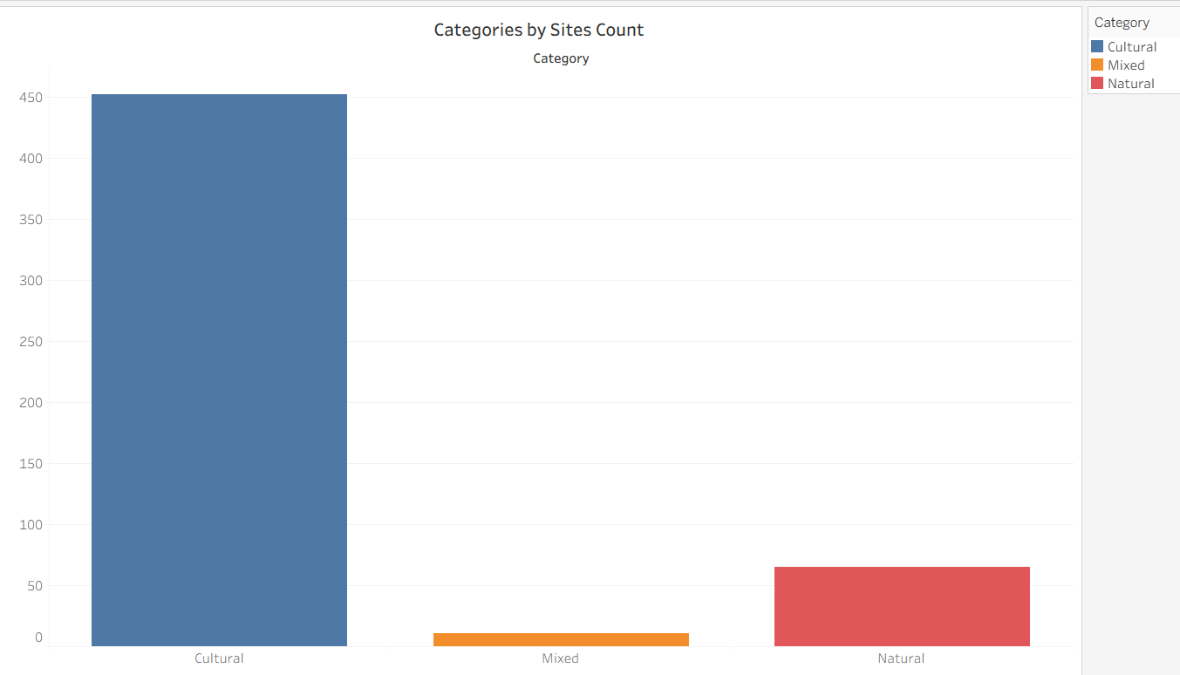
4 | Calculated Fields Used | COUNT([Site Name]) COUNT([Country]) COUNT([Category]) YEAR([Year of Inscription])  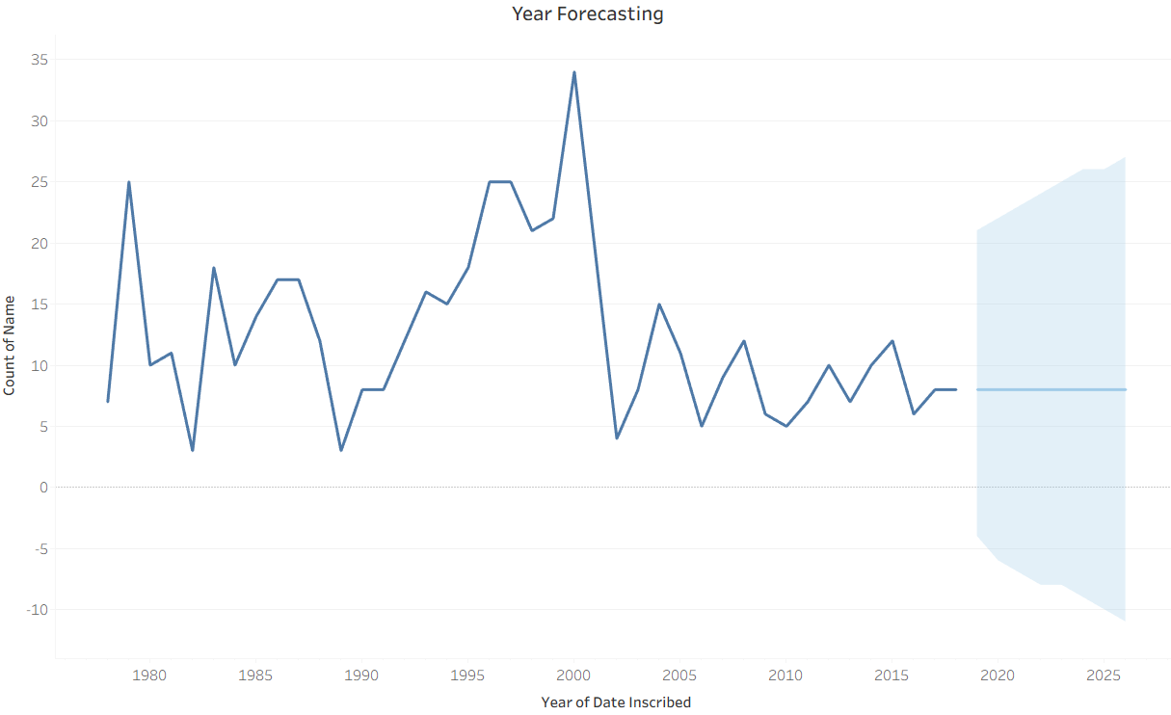
5 | Dashboard Design | 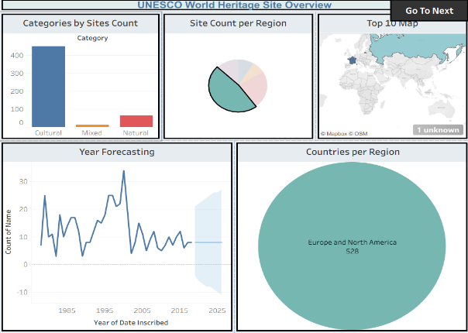  No. of Visualizations / Graphs – 5 (World Map, Category Pie Chart, Top 10 Countries Bar Chart, Year-wise Trend Line, Region Comparison Chart)  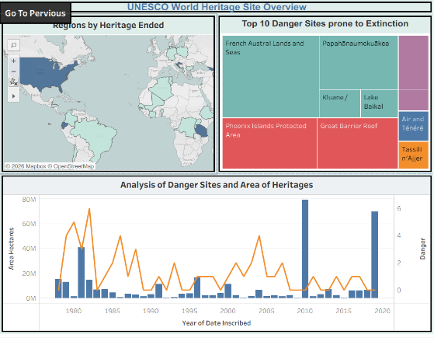
6 | Story Design | 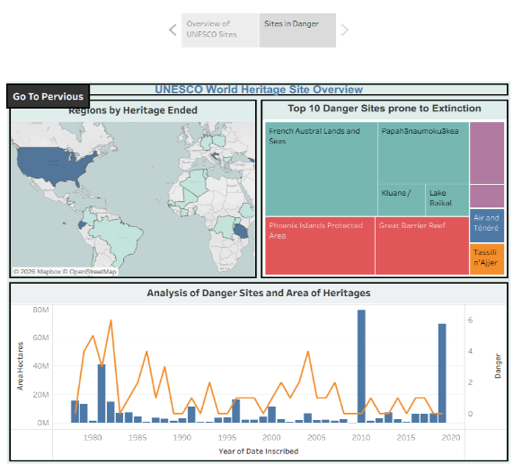  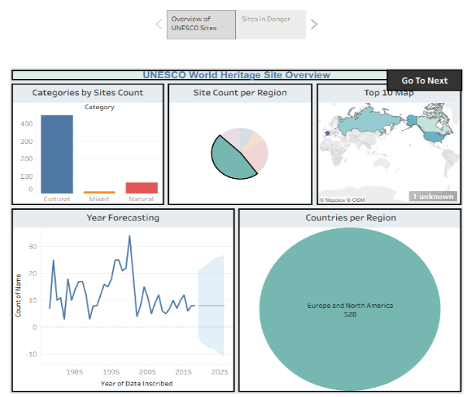  No. of Visualizations / Graphs – 4 (Global Overview, Category Analysis, Trend Analysis, Regional Comparison)

